Assignment #4

* I downloaded the image of Kate Libby’s 250MB Thumbdrive from Prof Ervin’s OneDrive Account.
* I downloaded and installed the Autopsy utility to help me with analysis. I referenced Prof Ervin’s lecture on Autopsy to assist myself.
* I created a new case called “kate_case_forensics_class”.
* Opened up Kate’s thumb drive by opening a new Image File / Virtual Machine.
* I started my analysis and asked myself, what are Kate and Dade’s plans?

1. What is Dade’s email address?

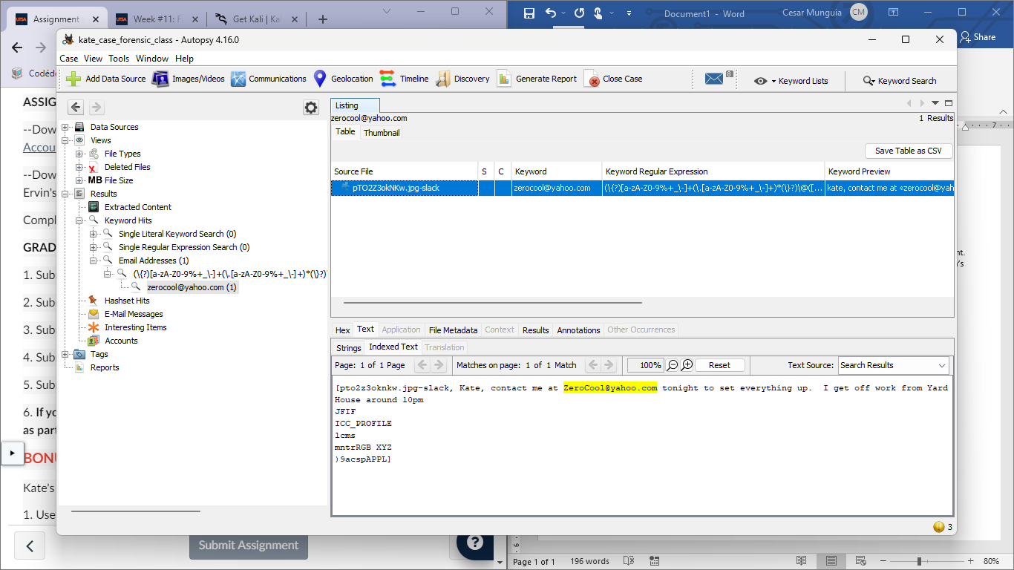

1. What poison is likely to be used?

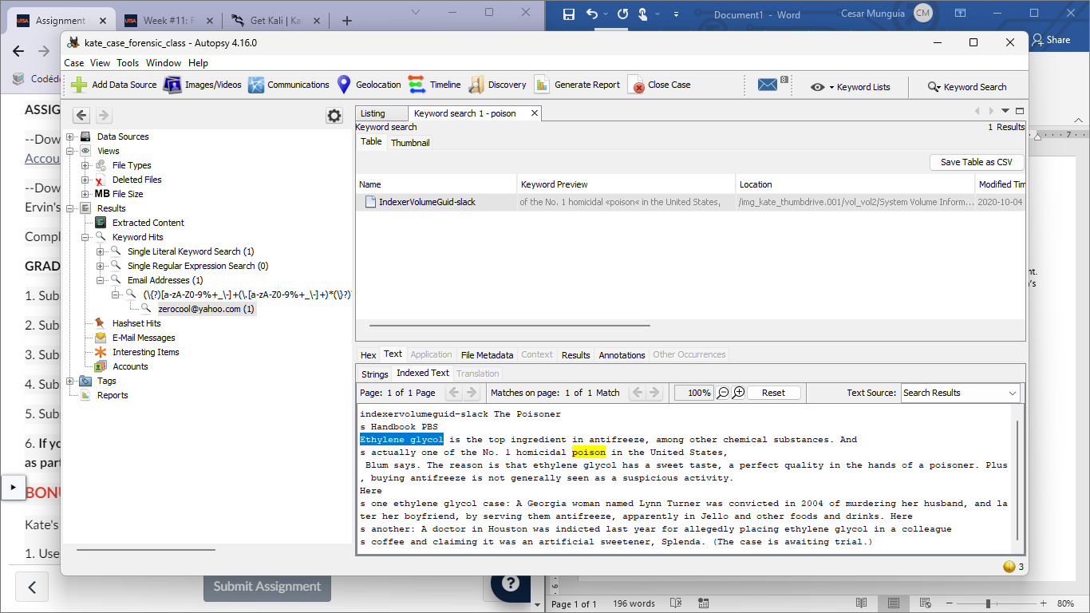

1. How Dade is to be paid and how much?

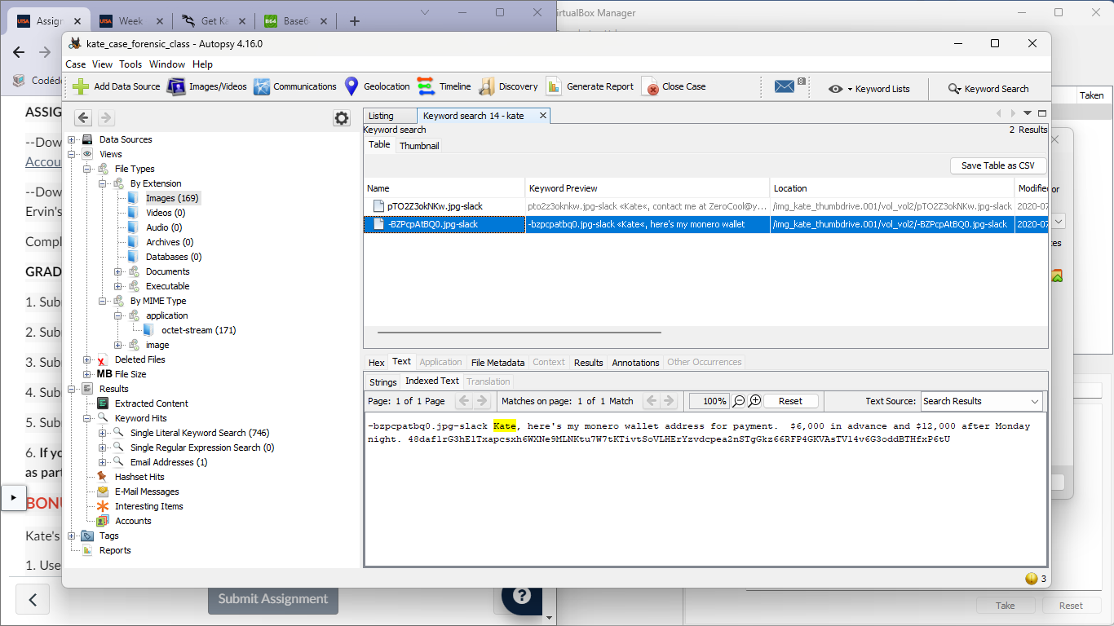

1. What is the day of the planned autopsy?

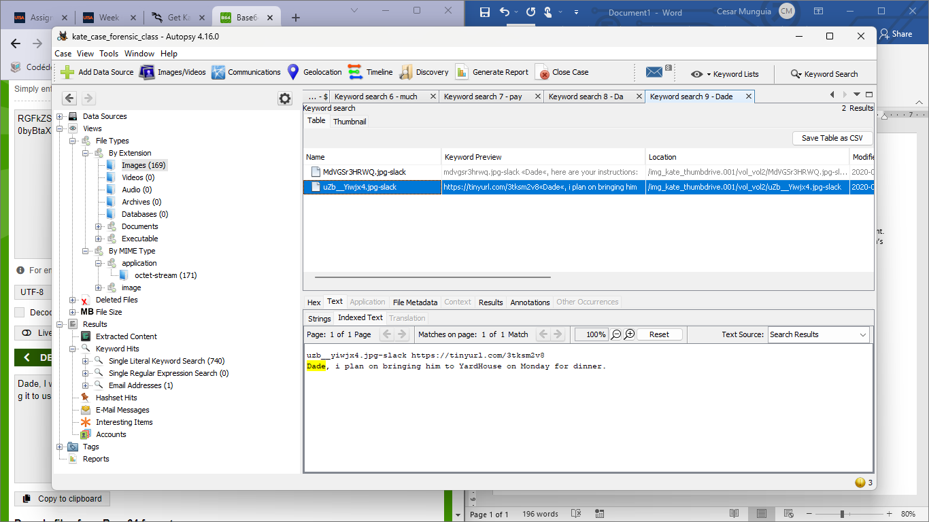

1. How will the poisoning take place?

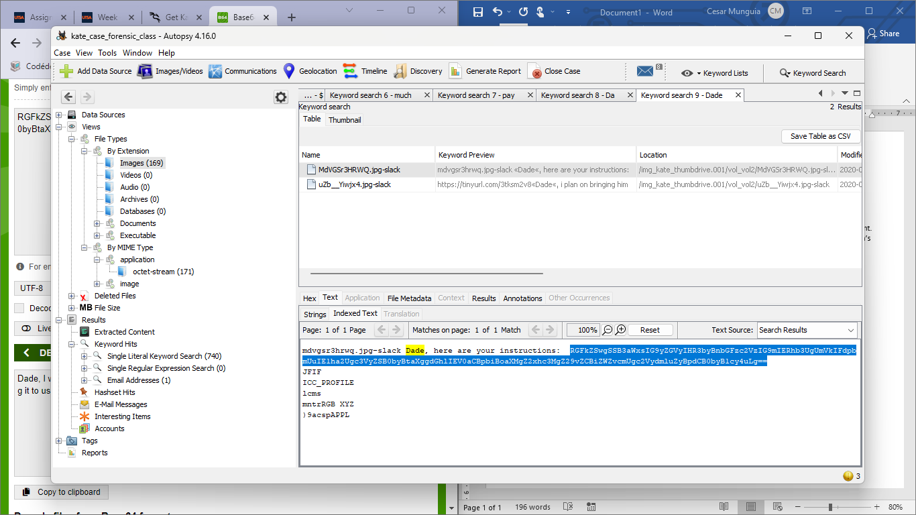

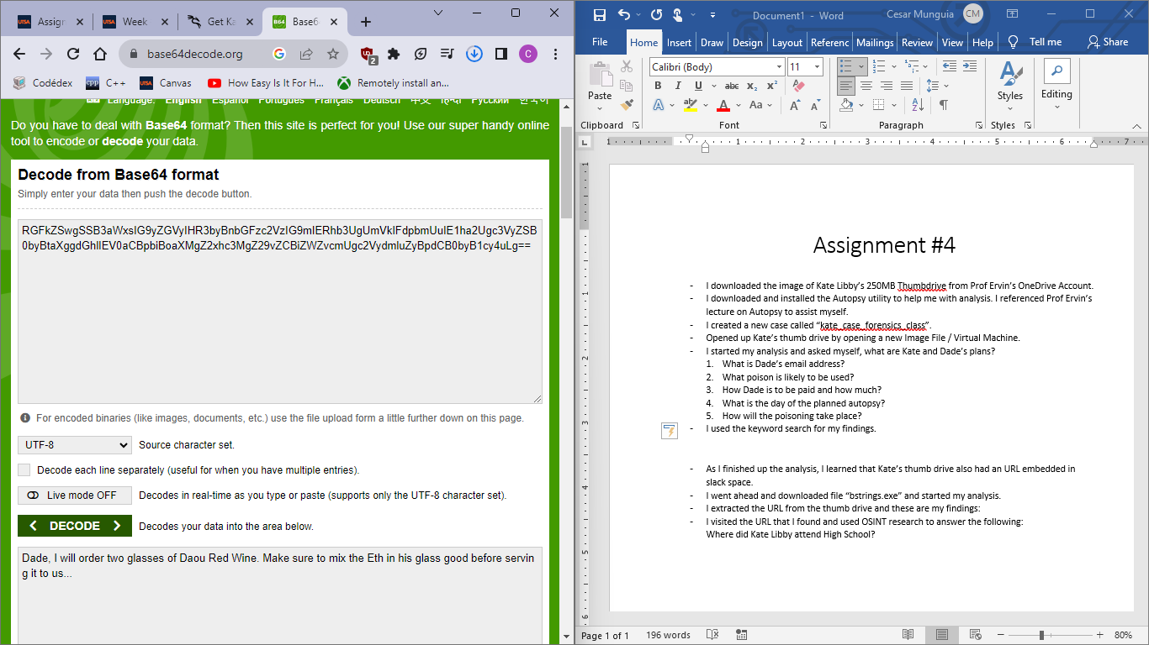

* I used the keyword search for my findings.
* As I finished up the analysis, I learned that Kate’s thumb drive also had an URL embedded in slack space.
* I went ahead and downloaded file “bstrings.exe” and started my analysis.
* I extracted the URL from the thumb drive and these are my findings:

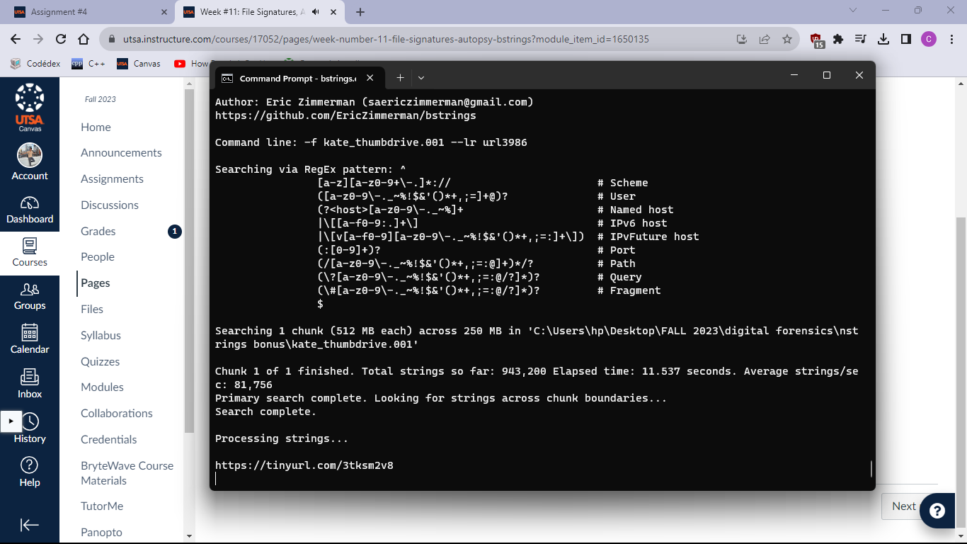

* I visited the URL that I found and used OSINT research to answer the following:

Where did Kate Libby attend High School?

Next thing I did was to open the URL which it showed me a picture of Kate Libby who is a character from the movie Hackers. Then I found that the actor’s name was Angeline Jolie and so I typed the name in google and entered the first Wikipedia page that showed me her biography. I used Ctrl+F to search for high school and this was my result.

